Table of Contents
Task 1 3
Output: 3
Results and Interpretation 4
Task 4. 6
Output: 6
Results and Interpretations: 6
Output: 7
Result and Interpretation 7
Task 6: 10
Output: 10
Results and Interpretation: 10
Task 7. 12
Output: 12
Results and Interpretation: 12
Notes: 16
Task 8: 17

Table of Figures.
Figure 1 London_borough 17
Figure 2 London_io 17
Figure 3 London_lifepoint 18
Figure 4 London_life_polygon 18
Figure 5 London_pop_time 19
Figure 6 Haringey Population 19
Figure 7 tq2278 20
Figure 8 Credit Union Shp file 20
Figure 9 Haringey boundary 21
Figure 10 Haringey gp 21
Figure 11 Haringey Road Links 21
Figure 12 Haringey 2km 22
Figure 13 London Ward Met per1000 22
Figure 14 Post Area 23
Figure 15 Underground stations 23
Figure 16 London Motorway 24

Task 1

Output:
Create Table london_guinness_book as
SELECT *
FROM london_boroughs

The above SQL script creates a copy table named london_guiness_book from the already pre existing london_boroughs table.
SELECT RecoverGeometryColumn('london_guinness_book', 'geometry', 27700, 'POLYGON', 'XY')

The above SQL script sets the column named geometry with SRID number 27700 and XY coordinates.
SELECT lua.name AS "London Borough",
lio.in_out AS Region,
ST_Area(lua.geometry) / 1000000.0 AS "Area (sq.Km)",
lua.pop / (ST_Area(lua.geometry) / 1000000.0) AS "Density: Population / sq.Km",
MbrMaxY(lua.geometry) AS North,
MbrMinY(lua.geometry) AS South,
MbrMaxX(lua.geometry) AS East,
MbrMinX(lua.geometry) AS West
From london_guinness_book AS lua
JOIN london_io AS lio ON (lua.In_out = lio.In_out)
WHERE lua.name IN
(SELECT name From london_guinness_book
WHERE ST_Area(geometry) IN
(SELECT Max(ST_Area(geometry)) FROM london_guinness_book
UNION
SELECT Min(ST_Area(geometry)) FROM london_guinness_book)
UNION SELECT name From london_guinness_book
WHERE pop / (ST_Area(geometry) / 1000000.0) IN
(SELECT Max(pop / (ST_Area(geometry) / 1000000.0)) FROM london_guinness_book
UNION
SELECT Min(pop / (ST_Area(geometry) / 1000000.0)) FROM london_guinness_book)
UNION SELECT name From london_guinness_book
WHERE MbrMaxY(geometry) IN
(SELECT Max(MbrMaxY(geometry)) FROM london_guinness_book)
UNION SELECT name From london_guinness_book
WHERE MbrMinY(geometry) IN
(SELECT Min(MbrMinY(geometry)) FROM london_guinness_book)
UNION SELECT name From london_guinness_book
WHERE MbrMaxX(geometry) IN
(SELECT Max(MbrMaxX(geometry)) FROM london_guinness_book)
UNION SELECT name From london_guinness_book
WHERE MbrMinX(geometry) IN
(SELECT Min(MbrMinX(geometry)) FROM london_guinness_book))
ORDER BY "Area (sq.Km)"
The above SQL script converts the area to sqkm.
The finds the maximum value of the North to serve as the Northernmost value.
It then finds the minimum value of the South to serve as the Southernmost value.
It then finds the maximum value of the East to serve as the Easternmost value.
Then finds the minimum value of the West to serve as the Westernmost value.
It then uses the UNION function to join the 4 coordinates with respective values.
Results and Interpretation:
London Borough | Region | Area (sq.Km) | Density: Population / sq.Km | North | South | East | West
City | Inner | 3.14938 | 2413.173069 | 182206.1 | 180406.7 | 533839.6 | 530967.7
Islington | Inner | 14.856653 | 14202.39178 | 187968.7 | 181659.1 | 533484.5 | 528832.4
Enfield | Outer | 82.200191 | 3860.088338 | 200933.9 | 191460.9 | 537813 | 525568.6
Croydon | Outer | 86.495565 | 4264.958548 | 171048.7 | 155850.8 | 539657.9 | 528185.7
Havering | Outer | 114.457267 | 2094.231384 | 194889.3 | 178410.9 | 561957.5 | 548106.9
Hillingdon | Outer | 115.701098 | 2435.586215 | 193619.8 | 173846.2 | 512764.7 | 503568.2
Bromley | Outer | 150.134858 | 2091.453007 | 173658.3 | 156480.9 | 550541.2 | 533531.5

From the above London Borough SQL output, we can discover that the Northernmost region is Enfield.
The Southernmost region is Croydon.
The Westernmost region is Hillingdon.
And the Easternmost region is Havering.
We will attach a London borough map to check if this tallies with real time data.
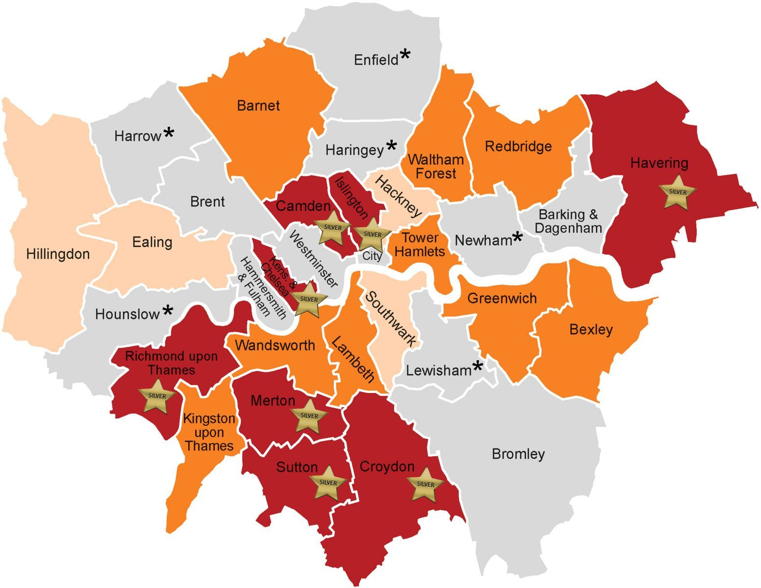
We can see from the above map that the Northernmost, Southernmost, Westernmost and Easternmost values align with the map.

Task 4.

Output:
SELECT io.in_out "Group",lua.name "London Borough Name",
count(distinct tube.station_na) "Number of Tube Stations",
count(distinct tube.line_name) "Number of Lines ",
count(distinct tube.station_na) / (ST_Area(lua.geometry) / 1000000.0) "Stations / sq.Km",
count(distinct tube.station_na) / (lua.pop/1000.0) "Stations / 1000 pop"
FROM UndergroundStations tube, london_guinness_book lua
JOIN london_io io ON lua.in_out = io.in_out
WHERE ST_Contains(lua.geometry,tube.geometry)
GROUP BY io.in_out,lua.name
ORDER BY io.in_out,lua.name

The above SQL query calculates how many London Underground stations and lines fall inside each London borough.
It groups the boroughs into Inner and Outer London using the london_io table.

Results and Interpretations:

Group | London Borough Name | Number of Tube Stations | Number of Lines | Stations / sq.Km | Stations / 1000 pop
Inner | Camden | 19 | 8 | 0.871988 | 0.084444
Inner | City | 14 | 8 | 4.445319 | 1.842105
Inner | Hackney | 1 | 1 | 0.052496 | 0.003967
Inner | Hammersmith and Fulham | 15 | 5 | 0.874428 | 0.08338
Inner | Haringey | 6 | 3 | 0.202714 | 0.023175
Inner | Islington | 11 | 6 | 0.740409 | 0.052133
Inner | Kensington and Chelsea | 11 | 5 | 0.888258 | 0.070558
Inner | Lambeth | 10 | 5 | 0.366981 | 0.032237
Inner | Lewisham | 2 | 1 | 0.05663 | 0.007102
Inner | Newham | 27 | 5 | 0.699879 | 0.08596
Inner | Southwark | 5 | 3 | 0.167149 | 0.017036
Inner | Tower Hamlets | 27 | 6 | 1.251449 | 0.102662
Inner | Wandsworth | 6 | 2 | 0.170357 | 0.019462
Inner | Westminster | 36 | 10 | 1.634131 | 0.160786
Outer | Barking and Dagenham | 5 | 2 | 0.132277 | 0.026233
Outer | Barnet | 12 | 1 | 0.138331 | 0.032967
Outer | Brent | 21 | 4 | 0.485744 | 0.06673
Outer | Ealing | 15 | 3 | 0.270054 | 0.044027
Outer | Enfield | 4 | 1 | 0.048662 | 0.012606
Outer | Greenwich | 5 | 2 | 0.099124 | 0.019223
Outer | Harrow | 10 | 4 | 0.198166 | 0.041254
Outer | Havering | 4 | 1 | 0.034948 | 0.016688
Outer | Hillingdon | 15 | 3 | 0.129644 | 0.053229
Outer | Hounslow | 9 | 2 | 0.159052 | 0.034736
Outer | Merton | 5 | 2 | 0.132891 | 0.024728
Outer | Redbridge | 10 | 1 | 0.177172 | 0.035137
Outer | Richmond upon Thames | 2 | 1 | 0.034036 | 0.010576
Outer | Waltham Forest | 4 | 2 | 0.103072 | 0.015232

The above SQL table output shows us the number of underground stations within London boroughs.
We observe that Westminister has the highest number of underground stations with 36 tube stations closely followed by Newham with 27 tube stations.
Westminister has the highest number of tube stations because it serves as the historic, political, and commercial heart of London. Therefore, it necessitates the need for high-density transport infrastructure to connect government, business, and tourist hubs.
Newham comes in close second due to the presence of Stratford and Royal Docks areas which houses tertiary institutions, health centres, business hubs, libraries, and an airport.
Hammersmith and Fulham have the least number of tube stations (1), closely followed by Richmond upon Thames, Waltham Forest and Enfield.
The reason Enfield has very few tube stations is because early private train companies developed strong surface routes linking major parts of the town, making it financially unnecessary to develop many underground rail tubes.

Output:
SELECT cu.cu_name AS "Credit Union Name",
lua.name AS "London Borough Name"
FROM credit_union AS cu, london_guinness_book AS lua
WHERE ST_Contains(lua.geometry, cu.geometry)
ORDER BY 2, 1

The above SQL query aliases Credit Union Name as cu.cu_name and Aliases London Borough Name as lua.name.
It then goes to answer which London contains each Credit Union.
Result and Interpretation:
Credit Union Name | London Borough Name
North West London Credit Union | Barnet
Brent Mutual | Brent
Lewisham Plus Credit Union2 | Bromley
London Mutual Credit Union4 | Camden
CMS Credit Union | Croydon
Croydon Caribbean Credit Union | Croydon
Brent Shrine Credit Union | Ealing
Greenwich and Bexley Credit Union | Greenwich
London Community Credit Union4 | Hackney
London Plus Credit Union | Hammersmith and Fulham
Liberty Credit Union Ltd. | Havering
Cube Credit Union | Hillingdon
Hillingdon Credit Union | Hillingdon
M For Money Credit Union | Hillingdon
Thamesbank Credit Union | Hillingdon
London Capital Credit Union | Islington
Your Credit Union | Kensington and Chelsea
London Mutual Credit Union3 | Lambeth
Wandsworth Community Credit Union Ltd. | Lambeth
Lewisham Plus Credit Union1 | Lewisham
New Cred | Newham
London Mutual Credit Union1 | Southwark
London Mutual Credit Union2 | Southwark
London Community Credit Union1 | Tower Hamlets
London Community Credit Union2 | Tower Hamlets
London Community Credit Union3 | Tower Hamlets
Rainbow Saver Credit Union | Waltham Forest
Waltham Forest Community Credit Union | Waltham Forest

The above SQL output shows then credit unions and the regions that house them.
We can see that Hillingdon has the highest number of credit unions which is largely due to the following factors:
Growth and Mergers: Originally formed in 1991 for council employees, Hillingdon Credit Union expanded its common bond to include residents in Hillingdon, Brent, Ealing, and surrounding areas. It later merged with Credit Union for Brent & Ealing (CUBE).

Rebranding to Community Bank: In 2022, Hillingdon Credit Union rebranded to London Community Bank to improve perception and understanding, better reflecting their community-focused, Not-for-profit financial services.

Addressing Financial Inclusion: They provide vital services for people with poor credit ratings or low incomes, supporting financial empowerment, according to Around Ealing.

Strong Community Backing: Supported by local government and volunteers, these institutions are viewed as safer and more stable alternatives to traditional banks during economic downturns, as noted by Logix.

Wide Eligibility: Membership is generally open to anyone who lives or works in the area, offering benefits such as affordable loans and payroll deductions, as described on the UNISON website.

Tower hamlets have the second highest number of credit unions with 3. This is because they are a predominantly low-income community and as such these credit unions provide ethical, affordable banking, saving and loan services tailored to residents and low-income workers.

Hackney, Brent, Ealing and Lewisham just have one credit union each due to high operating costs required to meet regulatory standards. Some credit unions in Hackney closed due to mismanagement, financial pressure, encouraging mergers with larger, more stable entities to maintain operations.

A more concise SQL script for task 4:

SELECT
cu.cu_name AS "Credit Union Name",
lua.name AS "London Borough Name"
FROM credit_union cu
JOIN london_guinness_book lua
ON ST_Contains(lua.geometry, cu.geometry)
ORDER BY lua.name, cu.cu_name;
The above script is more concise and readable (in my opinion) because:
It uses column names instead of numeric ORDER BY.
Replacing:
ORDER BY 2,1
With:
ORDER BY lua.name, cu.cu_name

This makes the code less ambiguous

Task 6:

Output:
SELECT mw.number AS Motorway,
lua.name AS "London Borough Name",
lio.in_out AS Region
From motorway AS mw
JOIN london_guinness_book AS lua ON
(ST_Intersects(mw.geometry, lua.geometry))
JOIN london_io AS lio ON
(lua.in_out = lio.in_out)
ORDER BY mw.number, lua.name

The above SQL query identifies which London boroughs each motorway passes through, and whether those boroughs are in Inner or Outer London.
It returns a list of:
• Motorway number
• London Borough Name
• Region (Inner or Outer London)

Results and Interpretation:

Motorway | London Borough Name | Region
M1 | Barnet | Outer
M1 | Harrow | Outer
M11 | Redbridge | Outer
M25 | Bromley | Outer
M25 | Enfield | Outer
M25 | Havering | Outer
M25 | Hillingdon | Outer
M4 | Hillingdon | Outer
M4 | Hounslow | Outer

Hillingdon notably stands out with the presence of 2 motorways due to its strategic location on London’s western edge, serving as the main gateway for traffic to and from Heathrow Airport, the M4 corridor and Oxford.

A more concise SQL script for task 6:

SELECT
mw.number AS Motorway,
lua.name AS "London Borough Name",
lio.in_out AS Region
FROM motorway mw
JOIN london_guinness_book lua
ON ST_Intersects(mw.geometry, lua.geometry)
JOIN london_io lio
ON lio.in_out = lua.in_out
ORDER BY mw.number, lua.name;

This removes unnecessary parentheses.
ST_Intersects() already returns a boolean. Extra parentheses around the ON condition adds no meaning and reduces readability.

Also, removing AS for table aliases is standard SQL practice and improves readability without changing behaviour.

Task 7.

Output:
SELECT mw.number AS Motorway,
tube3km.station_na AS "Station",
tube3km.line_name AS "Line",
(St_Distance(mw.geometry, tube1km.geometry) <= 1000.0) AS "distance to motorway < 1km",
(St_Distance(mw.geometry, tube2km.geometry) > 1000.0) AS "distance to motorway < 2km",
(St_Distance(mw.geometry, tube3km.geometry) > 2000.0) AS "distance to motorway <= 3km"
FROM motorway AS mw
JOIN UndergroundStations AS tube3km ON
(St_Distance(mw.geometry, tube3km.geometry) <= 3000.0)
LEFT JOIN UndergroundStations AS tube2km ON
(tube3km.pk_uid = tube2km.pk_uid AND
St_Distance(mw.geometry, tube2km.geometry) <= 2000.0)
LEFT JOIN UndergroundStations AS tube1km ON
(tube2km.pk_uid = tube1km.pk_uid AND
St_Distance(mw.geometry, tube1km.geometry) <= 1000.0)
ORDER BY 2

The above SQL query finds all Underground stations within 3 km of any motorway, then checks whether each of those stations is also:
• within 1 km of the motorway
• within 2 km of the motorway
• within 3 km of the motorway

Results and Interpretation:

Motorway | Station | Line | distance to motorway < 1km | distance to motorway < 2km | distance to motorway <= 3km
M4 | Acton Town Underground Station | Piccadilly |  | 1 | 0
M4 | Acton Town Underground Station | District |  | 1 | 0
M4 | Boston Manor Underground Station | Piccadilly | 1 | 0 | 0
M1 | Brent Cross Underground Station | Northern |  | 1 | 0
M11 | Buckhurst Hill | Central Line |  | 1 | 0
M1 | Burnt Oak Underground Station | Northern |  | 1 | 0
M11 | Chigwell | Central Line | 1 | 0 | 0
M4 | Chiswick Park Underground Station | District | 1 | 0 | 0
M25 | Chorleywood Underground Station | Metropolitan |  | 1 | 0
M1 | Colindale Underground Station | Northern | 1 | 0 | 0
M11 | Debden | Central Line | 1 | 0 | 0
M1 | Dollis Hill Underground Station | Jubilee |  |  | 1
M4 | Ealing Broadway | Central Line |  |  | 1
M4 | Ealing Broadway Underground Station | District |  |  | 1
M4 | Ealing Common Underground Station | Piccadilly |  | 1 | 0
M4 | Ealing Common Underground Station | District |  | 1 | 0
M1 | Edgware | Northern |  | 1 | 0
M11 | Epping | Central Line |  | 1 | 0
M25 | Epping | Central Line |  | 1 | 0
M1 | Finchley Central Underground Station | Northern |  |  | 1
M11 | Gants Hill | Central Line |  |  | 1
M1 | Golders Green Underground Station | Northern |  |  | 1
M11 | Grange Hill | Central Line |  |  | 1
M4 | Gunnersbury Underground Station | District | 1 | 0 | 0
M11 | Hainault | Central Line |  |  | 1
M4 | Hatton Cross Underground Station | Piccadilly |  |  | 1
M4 | Heathrow Terminal 4 Underground Station | Piccadilly |  |  | 1
M4 | Heathrow Terminals 1-2-3 Underground Station | Piccadilly |  | 1 | 0
M1 | Hendon Central Underground Station | Northern | 1 | 0 | 0
M4 | Hounslow Central Underground Station | Piccadilly |  |  | 1
M4 | Hounslow East Underground Station | Piccadilly |  | 1 | 0
M4 | Hounslow West Underground Station | Piccadilly |  | 1 | 0
M4 | Kew Gardens Underground Station | District |  | 1 | 0
M1 | Kingsbury Underground Station | Jubilee |  |  | 1
M11 | Loughton | Central Line |  | 1 | 0
M1 | Mill Hill East Underground Station | Northern |  | 1 | 0
M1 | Neasden Underground Station | Jubilee |  |  | 1
M4 | North Ealing Underground Station | Piccadilly |  |  | 1
M4 | Northfields Underground Station | Piccadilly |  | 1 | 0
M4 | Osterley Underground Station | Piccadilly |  | 1 | 0
M11 | Redbridge | Central Line |  | 1 | 0
M25 | Rickmansworth Underground Station | Metropolitan |  | 1 | 0
M11 | Roding Valley | Central Line | 1 | 0 | 0
M11 | Snaresbrook | Central Line |  | 1 | 0
M4 | South Ealing Underground Station | Piccadilly |  | 1 | 0
M11 | South Woodford | Central Line | 1 | 0 | 0
M4 | Stamford Brook Underground Station | District |  |  | 1
M1 | Stanmore Underground Station | Jubilee |  | 1 | 0
M25 | Terminal 5 | Piccadilly | 1 | 0 | 0
M4 | Terminal 5 | Piccadilly |  |  | 1
M11 | Theydon Bois | Central Line | 1 | 0 | 0
M25 | Theydon Bois | Central Line |  | 1 | 0
M4 | Turnham Green Underground Station | Piccadilly |  | 1 | 0
M4 | Turnham Green Underground Station | District |  | 1 | 0
M25 | Upminster Underground Station | District |  |  | 1
M25 | Uxbridge Underground Station | Metropolitan |  | 1 | 0
M25 | Uxbridge Underground Station | Piccadilly |  | 1 | 0
M11 | Wanstead | Central Line |  |  | 1
M4 | West Acton | Central Line |  |  | 1
M1 | Willesden Green Underground Station | Jubilee |  |  | 1
M11 | Woodford | Central Line |  | 1 | 0

We will specifically mention the underground stations within 1 km of motorways which are: Boston Manor Underground Station, Chigwell Station, Chiswick Park Underground Station, Colindale Underground station, Debden Station, Gunnersbury Underground Station, Hendon Central Underground Station, Roding Valley Station, South Woodford Station, Terminal 5 and Theydon bois Station.

A more concise SQL script for Task 7:

SELECT
mw.number AS Motorway,
tube.station_na AS "Station",
tube.line_name AS "Line",
ROUND(ST_Distance(mw.geometry, tube.geometry) / 1000.0, 2) AS "Distance (km)",
CASE
WHEN ST_Distance(mw.geometry, tube.geometry) <= 1000.0 THEN '<= 1km'
WHEN ST_Distance(mw.geometry, tube.geometry) <= 2000.0 THEN '1–2km'
WHEN ST_Distance(mw.geometry, tube.geometry) <= 3000.0 THEN '2–3km'
ELSE '> 3km'
END AS "Distance band"
FROM motorway AS mw
JOIN UndergroundStations AS tube
ON ST_Distance(mw.geometry, tube.geometry) <= 3000.0
ORDER BY 2;

This is more concise because there is no more need for three copies of UndergroundStations (tube1km, tube2km and tube3km)- we join once and classify with CASE.
Also, output is easier to read and use in filtering/grouping (e.g, WHERE Distance band= ‘1-2km’)

Notes:

It is important to note that there are other apps that can run the queries that were ran with Spatialite SQL.
QGIS can connect to Spatialite databases and work with them.
Another software package that works well with Spatialite-backed data is ArcGIS pro/ArcMap, although it may be less predictable than QGIS for Spatialite metadata operations.

If the developer wants same ideas with similar function names, PostgreSQL +PostGIS can work.

Task 8:

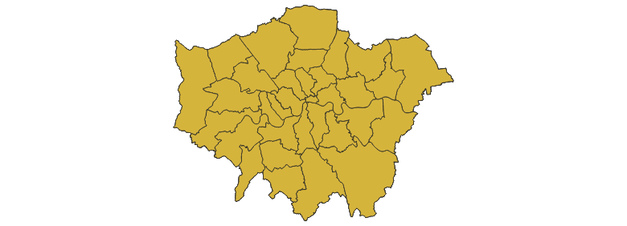
Figure 1 London_borough
The above map is the London borough map.

Figure 2 London_io
The above map shows the inner and outer London demarcation.

Figure 3 London_lifepoint
The above map shows the lifepoints across the London borough.

Figure 4 London_life_polygon

Figure 5 London_pop_time

Figure 6 Haringey Population
The above map shows the Haringey Population and their location in London.

Figure 7 tq2278

Figure 8 Credit Union Shp file
The above map shows the credit unions and their locations across London.


Figure 9 Haringey boundary
The above map shows Haringey boundary.
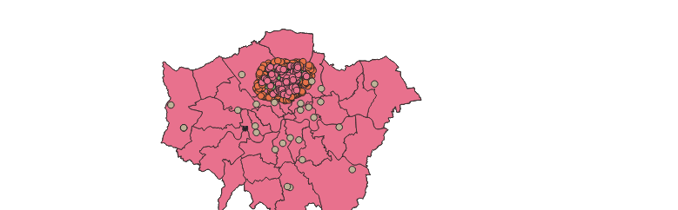
Figure 10 Haringey gp
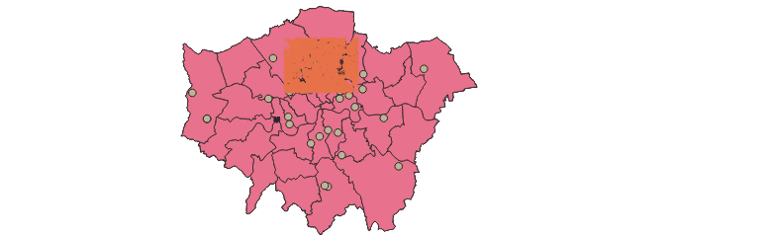
Figure 11 Haringey Road Links
The above image shows Haringey Road links.
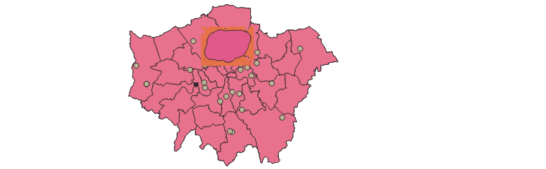
Figure 12 Haringey 2km
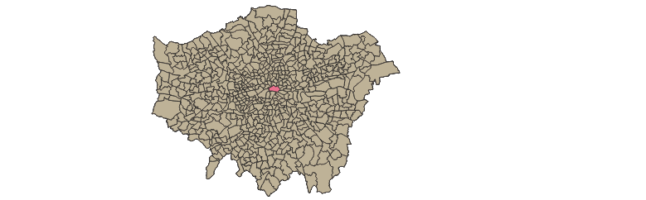
Figure 13 London Ward Met per1000
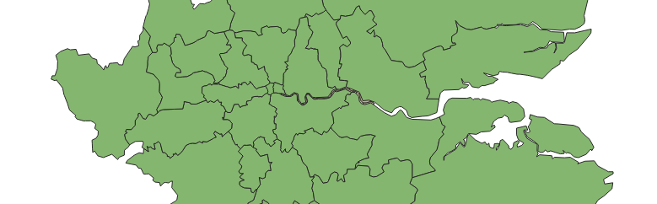
Figure 14 Post Area
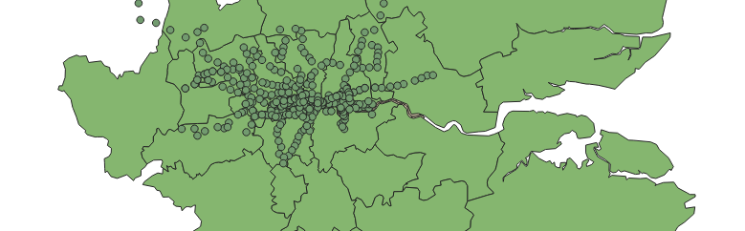
Figure 15 Underground stations
The above map shows the underground stations across the London borough.
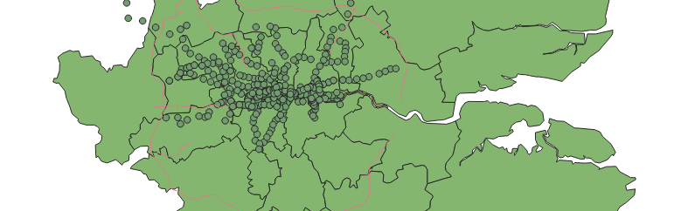
Figure 16 London Motorway
The pink borderline shows the motorway lines across the London borough.

